**Lab Exercise 7– Creating Pods in Kubernetes**

Below is a lab exercise that will help you understand and practice creating pods in Kubernetes:

**Task 1: Start Kubernetes in Docker-Desktop**

* Start Kubernetes service in Docker-Desktop

**Task 2: Creating a Simple Pod**

* Create a simple YAML manifest file named pod.yaml to define a basic Pod in Kubernetes. An example of the file content is as follows:

apiVersion: v1

kind: Pod

metadata:

  name: my-nginx-pod

  labels:

    app: lbnginx

spec:

  containers:

  - name: nginx-container

    image: nginx

Apply the Pod configuration using the following command:

kubectl apply -f pod.yaml

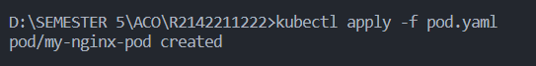

Check the status of the Pod using the following command:

kubectl get pods

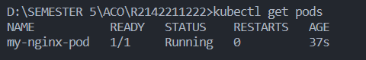

Task 3: Accessing the Pod

Access the Pod by using port forwarding to the container. Run the following command:

kubectl port-forward my-nginx-pod 8080:80

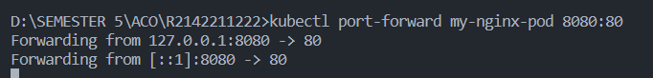

Access the Nginx server running in the Pod by opening a web browser and navigating to http://localhost:8080.

**Task 4: Exploring Pod Details**

Retrieve detailed information about the Pod using the following command:

kubectl describe pod my-nginx-pod

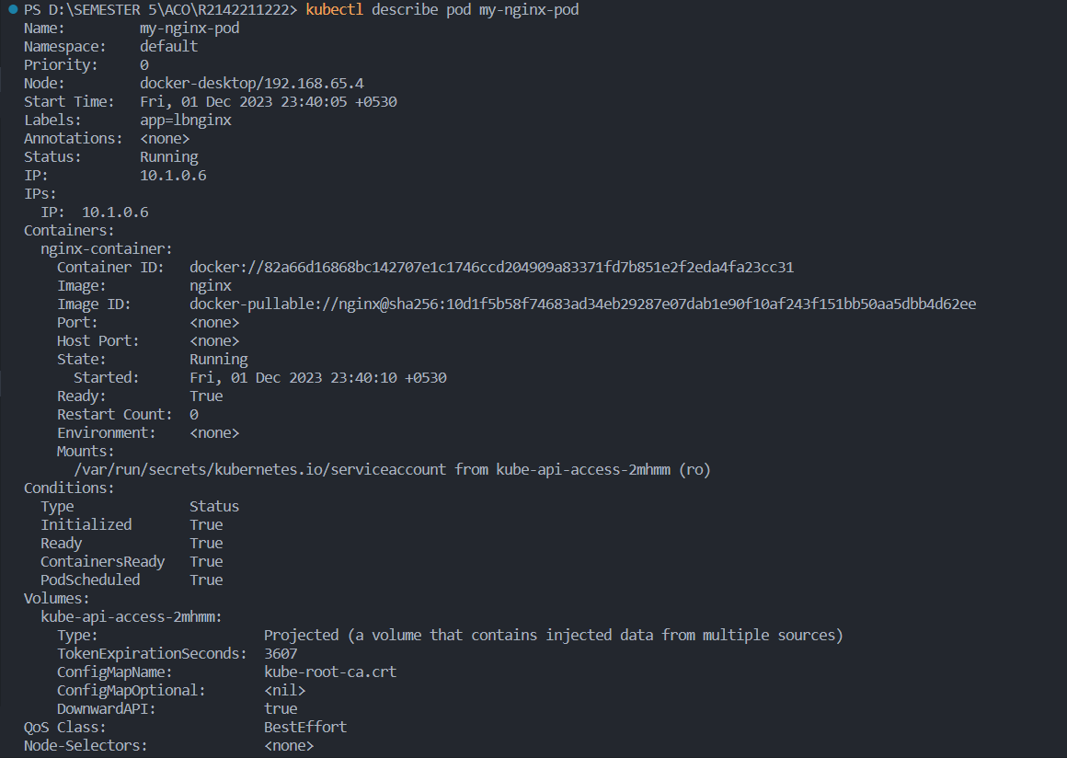

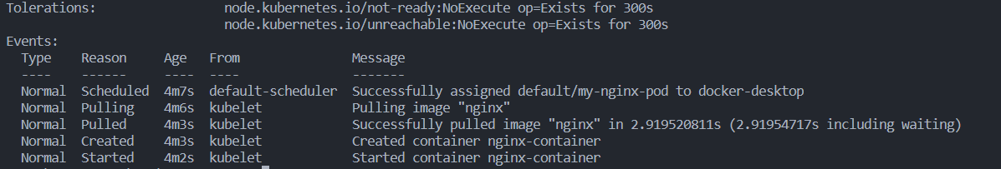

Check the logs of the Pod to understand its behavior using the following command:

kubectl logs my-nginx-pod

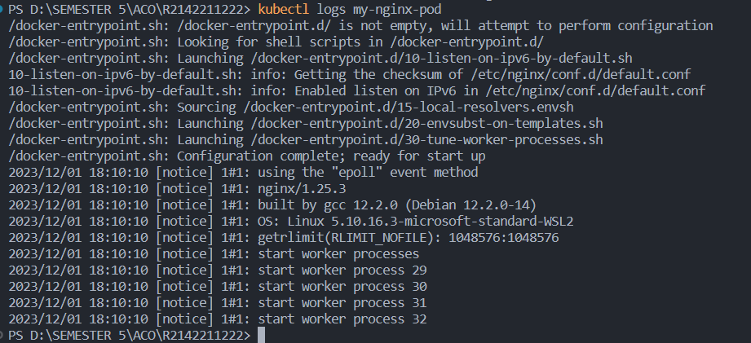

**Task 5: Deleting the Pod**

Delete the Pod using the following command:

kubectl delete pod my-nginx-pod



Verify that the Pod has been deleted by running the kubectl get pods command.

**Task 6: Advanced Pod Configuration**

* Experiment with advanced Pod configuration options such as environment variables, volume mounts, resource limits, and labels.
* Update the Pod manifest file and apply the changes to the Kubernetes cluster.

**Task 7: Cleanup**

Delete any remaining Pods, services, and deployments created during the exercise using the appropriate kubectl delete commands.

**Task 8: Documentation and Best Practices**

Document your findings and the best practices for creating and managing Pods in Kubernetes.

Through this exercise, you'll gain a better understanding of how to create, manage, and interact with Pods in Kubernetes. Adjust the exercise based on your specific use case and requirements.